Lab 4: Verification of Superposition Theorem

|  |  |
| --- | --- |
| Submitted By | Name: Townim Faisal  ID: 1721327042  Section: 08  Group: 07 |

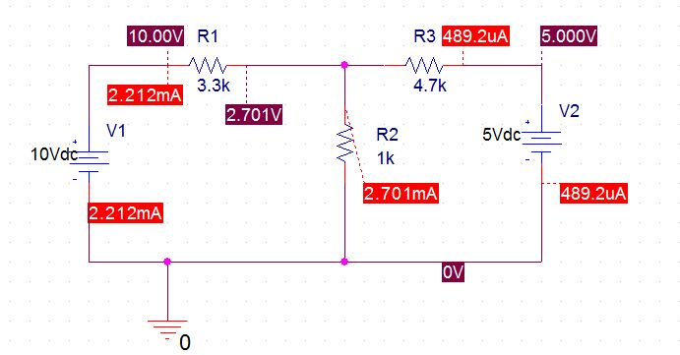

Figure: Circuit 1

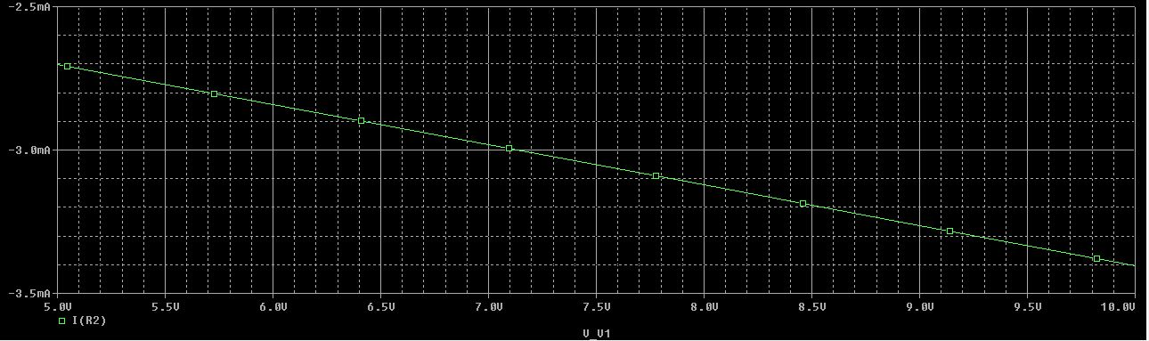

Figure: I_R2 vs V_V1

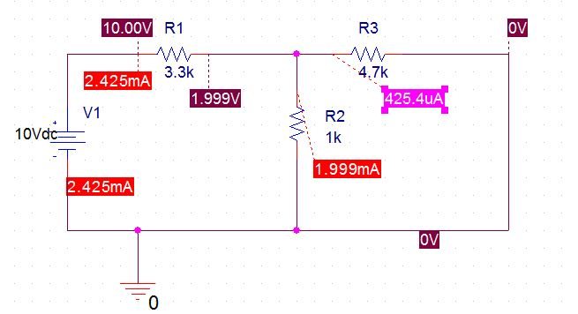

Figure: Circuit 2

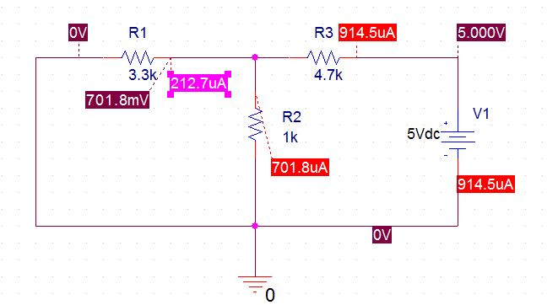

Figure: Circuit 3